**Q5.**clear all; close all; clc;%% Generate a distribution for each covariance matrix defined.

load('F:\Fall 2017\Math Foundations for ML\Assignments\Homework 10\hw10p4_data.mat')

%% Generating variables..using the covariances and means in Q2.

mu1 = [0;1];

sigma1 = [3,-6;-6,18];

% rng default % for reproducability

r1 = mvnrnd(mu1,sigma1,1000);

mu2 = [1;0];

sigma2 = [1,0;0,1];

% rng default

r2 = mvnrnd(mu2,sigma2,1000);

r1 = r1';

r2 = r2';

%% Each data point in r1 and r2 are to be compared with X1 and X2 separately..

for j = 1:1000

for i = 1:100

d1(j,i) = sqrt((r1(1,j) - X1(1,i))^2 + (r1(2,j) - X1(2,i))^2);

end

for i = 1:100

d2(j,i) = sqrt((r1(1,j) - X2(1,i))^2 + (r1(2,j) - X2(2,i))^2);

end

for i = 1:100

d3(j,i) = sqrt((r2(1,j) - X1(1,i))^2 + (r2(2,j) - X1(2,i))^2);

end

for i = 1:100

d4(j,i) = sqrt((r2(1,j) - X2(1,i))^2 + (r2(2,j) - X2(2,i))^2);

end

end

for k = 1:1000

mind1(k) = min(d1(k,:));

end

for k = 1:1000

mind2(k) = min(d2(k,:));

end

for k = 1:1000

mind3(k) = min(d3(k,:));

end

for k = 1:1000

mind4(k) = min(d4(k,:));

end

q1 = 0; q2 = 0; q3 = 0; q4 = 0;

%% bo (blue circles) -- belongs to X1 and k* (black stars) -- belongs to X2.

for k = 1:1000

if mind1(k)<mind2(k)

plot(r1(1,k),r1(2,k),'bo'); hold on;

q1 = q1+1;

end

if mind1(k)> mind2(k)

plot(r1(1,k),r1(2,k),'k*'); hold on;

q2 = q2+1;

end

end

for k = 1:1000

if mind3(k)<mind4(k)

plot(r2(1,k),r2(2,k),'bo'); hold on;

q3 = q3+1;

end

if mind3(k)> mind4(k)

plot(r2(1,k),r2(2,k),'k*'); hold on;

q4 = q4+1;

end

end

GENN = ((q2 + q3)/2000)*100; %This is GE for Nearest Neighbours case.

%% Calculating GE for Bayes Classifer..

syms x1 x2

f1(x1,x2) = (1/(2*pi*sqrt(18)))*(exp(-(1/36)*(18*x1^2 + 3*x2^2 + 12*x1*x2 - 12*x1 - 6*x2 + 3)));

f2(x1,x2) = (1/(2*pi))*(exp(-0.5*(x1^2 + x2^2 - 2*x1 + 1)));

err = 0;

for j = 1:1000

if double(f1(r1(1,j),r1(2,j))) < double(f2(r1(1,j),r1(2,j)))

err = err + 1;

end

if double(f1(r2(1,j),r2(2,j))) > double(f2(r2(1,j),r2(2,j)))

err = err + 1;

end

end

GEBC = (err/2000)*100;

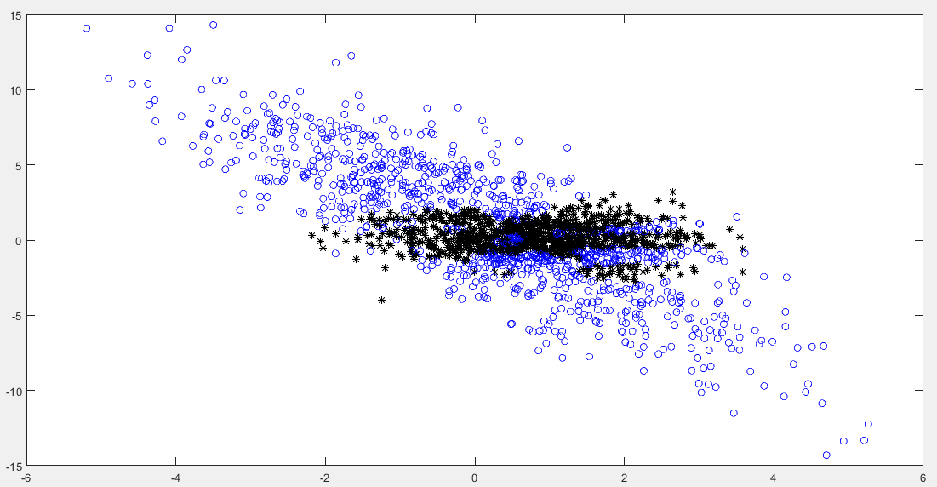

Generalization Error:

For Bayes classifier: 17%  
For Nearest Neighbours: 27.4%